BRAD Station Tracking Software Instructions

Written by: Mathew Clutter

If you are reading this, you likely want to track a balloon using the Montana Space Grant’s BOREALIS program’s ground station. This document will lay out the steps to use the software associated with the ground station to track a balloon.

1. To launch the GUI, you must have Python 3 installed.
   1. If you do not have Python download, download, and run the installer from the following link: <https://www.python.org/downloads/>
2. Once you have Python 3 installed, run the installer.bat file to install the needed python libraries
3. Launch the GUI by running main.py
4. Select or enter your Balloon IMEI in the top left corner
   1. 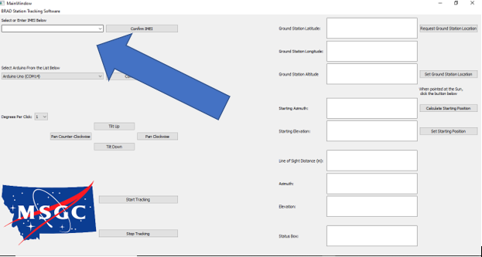
   2. After selecting your balloon’s IMEI, hit the confirm IMEI button.
      1. Ensure that the date in the status box in the bottom left corner is the correct date. If not, the balloon will not be tracked properly.
5. Select and connect the Arduino in the box below the IMEI selection
   1. 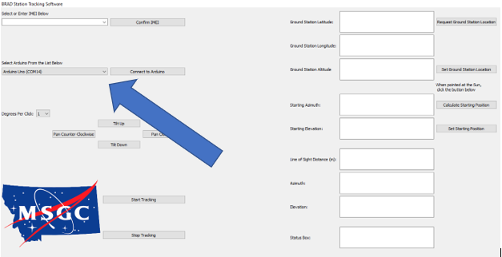
   2. Ensure that the Arduino connected to the ground station is selected and press the “Connect to Arduino” button.
6. Obtain the GPS location of the Ground Station setup
   1. Click the “Request Ground Station Location” button in the top left or manually enter the location of the ground station in the boxes in the top right corner.
      1. 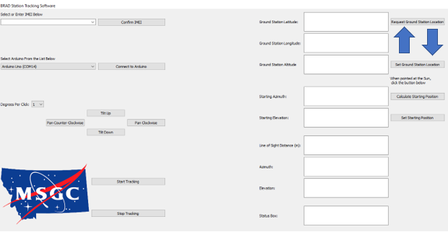
         1. After obtaining the location of the ground station, hit the “Set Ground Station Location” button.
7. Use the adjustment buttons to point the solar sight at the sun
   1. 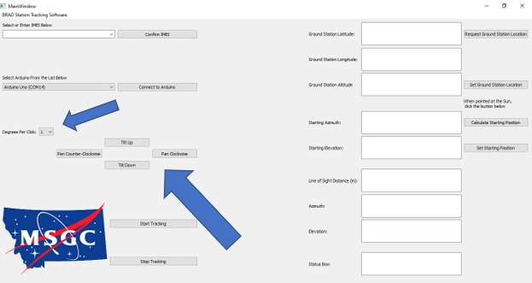
   2. Adjust the size of the motor movement using the “Degrees Per Click” box.
      1. Ensure that the sun is centered in the solar sight.
8. Set the starting position that the antennas are pointing at.
   1. Ensure that the ground station location is set and the solar sight is pointing at the sun.
   2. Click the “Calculate Starting Position” button on the right side of the screen.
      1. 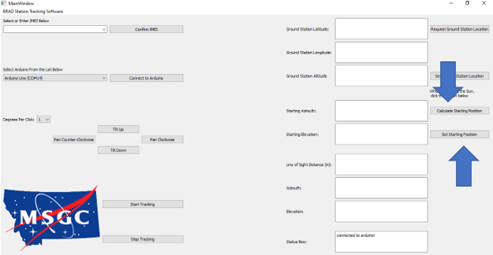
      2. Once the starting position is calculated, hit the “Set Starting Position” button.
9. Hit the “Start Tracking” button in the bottom left to begin tracking the balloon!
   1. The “Stop Tracking” button will end the tracking
      1. 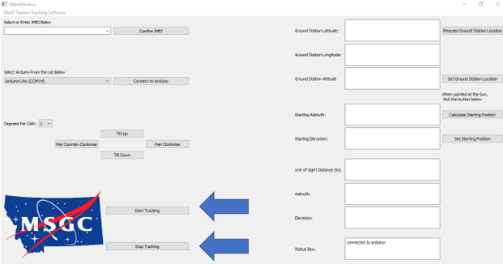

Other items to note:

* Internet connection is required to run the ground station tracker.
* Ensure that your Iridium is on and actively pinging the server before starting tracking.
  + <https://borealis.rci.montana.edu/tracking>
* Additional information and error messages will appear in the bottom right corner in the status box. If something is not working, this may help you to debug what the issue is.
* You must have the Arduino connected when starting the software.
* The tracker is designed to work with Windows; however, it should run on Mac/Linux if you pip install the needed libraries yourself.
* If you have two monitors connected when running the tracker, you may need to resize the window to get it to scale correctly.
* If you have any other questions or concerns, contact me at: [mathewclutter@gmail.com](mailto:mathewclutter@gmail.com)